WHY IS THERE A NEED FOR A STRATEGIC OR BUSINESS PLAN?

The words Strategic or Business plans seem like a scary or daunting concept and people don’t often understand what they are or their importance in an association
“The trouble with not having a goal is that you can spend your life running up and down the field and never scoring”

The aim of this document is to explain the difference between a Strategic Plan and a Business Plan and show why both are important to the association, club or an organisation.

Planning is paramount to the short and long term success of any association.

Strategic Planning helps the organisation;

- Set out long term goals which will assist to develop the association

- Develop a budget, an annual plan of attack, any additional plans required and provide employed staff work programs and KPIs

- From going off track and undertaking every ad hoc or exciting idea that might pop up. Reality is, while these ideas might be great, they may not be a priority or beneficial to the big picture of the association, or even take up valuable resource that could be used elsewhere.

- Keep an accurate record of development. What has worked, what hasn’t, what can be improved on

- With knowledge sharing. It allows for a consistent level of development over a period of time, especially if board members or employees depart their current roles. New board members or employees can see where the association is, what needs to be done, who is to do it. It saves reinventing the wheel.

- Shows the members the direction the association is heading and what projects are coming up that may be beneficial to them, and how they fit into the bigger picture.

WHAT IS A STRATEGIC PLAN?

Simply put a strategic plan is you long term goals put down on paper. A Strategic plan should includes

A Vision
A Mission
The Assns values
Key priorities
The areas the association wants to develop
Focus
What you want to focus on within each key priority
Objectives
An overall summary of what you want to achieve from each focus

WHAT IS A BUSINESS PLAN?
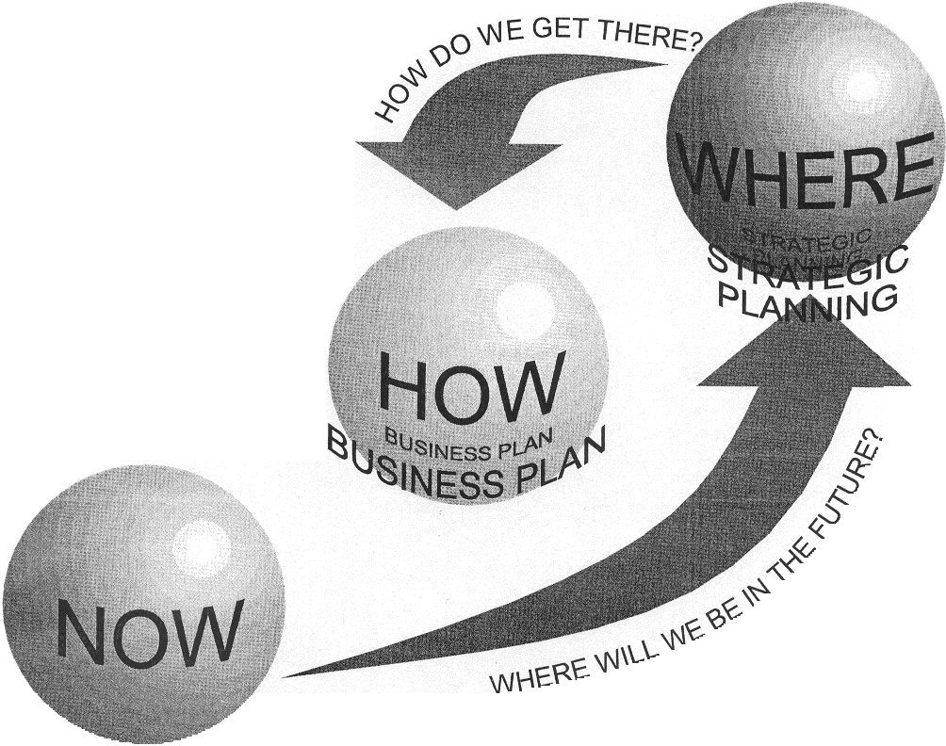

After you have created a Strategic plan, the next step is to create a Business plan (sometimes referred to as an operational plan)

A Business plan is the bigger picture. It is a map or a blueprint for the Association, its employees and its members to work from.
It fleshes out the plan with the additional detail we require.

In a nutshell, it is “HOW” the association will reach their long term goals.

To see how a Business plan expands on our Strategic Plan, please refer to the below diagram

A Vision
A Mission
The Assns values
Key priorities
The areas the association wants to develop
Focus
What you want to focus on within each key priority
Objectives
An overall summary of what you want to achieve from each focus
Actions
How we are going to achieve our objectives & measure them

As shown in the above diagrams, a Business Plan puts in place “actions” for each objective set out in the Strategic Plan. The “actions” will show us how we are going to achieve our objectives.
The number of “actions” per “objective” is up to each association and what it thinks it is capable of achieving.

With every “action” we also need to include the following so that it is fully understood how the action is going to be achieved.
- When (time frame)
- Who (responsibility)
- Capability (Budget or other resource required)
- Measures (expected outcomes)
Example

Objective  (from the strat plan) | Create an umpire & scorer development plan providing for all members & abilities
Actions | Time frame | Responsibility | Resource | Expected outcome(s)
- Submit a KiwiSport application for Kiwi Sox Junior Umpiring & scoring program | Implemented in 2013 season and reviewed post season for future planning | Convener | - Convener & SNZ Softball Officer time,  - Funding Grant from Sport southland | Program to be fully funded by Kiwi Sport and a total of 15 participants / mentors to partake
- Creation of a policy that requires membership to undertake a basic umpire session | Implemented in 2013 season | Convener &  Chief Umpire | - Convener, & Chief Umpire time  - Basic Printing costs | 100 % of membership to undertake the session

On a Final Note

Strategic Plans and Business Plans are created to become “live” documents – as in they should be used to help the association grow in its development, capability, profile etc.

Often Associations, clubs or other organisations will

- Create a Strategic Plan but won’t create a Business plan – so they are missing the actual detail of “how” they are going to achieve their goals. This is like filling you car with only half the petrol you require to get to your destination.

- Create both plans but won’t refer to them and go off on ad hoc projects, tasks or ideas. This doesn’t allow an association, club or organisation to create momentum in its development and also doesn’t allow the membership to see what its long term goals are.
So we have filled the car, we have told our friends where we are heading, but don’t turn up to our destination as we got lost along the way as we didn’t follow our road map.

- Think that a strategic or business plan is set in stone. They are not. Like anything, sometimes our focus or areas of importance change, and these plans need to be flexible to cater for this. This doesn’t mean scrapping the whole document, but what it does mean is updating the plans (and probably more specifically the objectives or actions in some of our plan) to reflect the capability and priorities of the association, club or organisation and its members.

